Living Things and The Environment

I pledge on my honor that I have neither given nor received unauthorized aid on this quiz.

Student signature X_________________________________________________________

Circle the word or phrase in each set of parentheses that correctly completes the sentence.

Limiting factors cause the sizes of populations to **(stop decreasing / stop increasing)** or to **(increase / decrease)**. (2 points)

Groundhogs inhabiting a meadow environment drink water and rely on plants, including clover, for food. Which of the following terms describe **both** the water and the clover that the groundhogs consume? Choose all that apply. (2 points)

* 1. limiting factors
  2. abiotic factors
  3. biotic factors
  4. resources

For each word listed, write whether it is from the **biotic** or **abiotic** part of the environment. (0.5 points each, 4 points total)

* 1. An alligator ___________
  2. Temperature ___________
  3. Plants ___________
  4. Rocks ___________
  5. Air ___________
  6. A tree___________
  7. A cat ___________
  8. A dead log ___________

Place the following terms in the appropriate location within the graphic organizer. Provide an example **and** explain what each level means. (8 points)  
***Population Ecosystem Organism Community***

|  |
| --- |
|  |
|  |
|  |

**Use the information and the graph below to answer questions below.**

The American Plains bison is a grasslands species that eats mostly grasses. By the late 1800s, hunting came close to causing this animal to disappear from the western United States. In the early 1900s, landowners and the U.S. government took steps to save the bison. The graph shows data collected in northern Yellowstone National Park between 1902 and 1915.

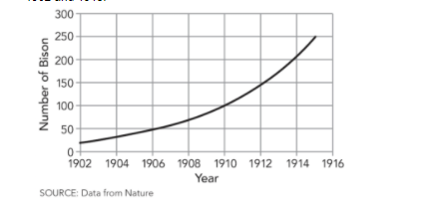

Which of the following events could have caused the change shown in the graph? Choose all that apply. (2 points)

1. natural disaster
2. decrease in food
3. increase in shelter
4. departure of bison
5. decrease in hunting of bison

A drought is a long period of abnormally low precipitation. Suppose a drought occurred in Yellowstone National Park from 1916 to 1917. Predict how the bison population would change in terms of the effect on resource availability. (2 points)